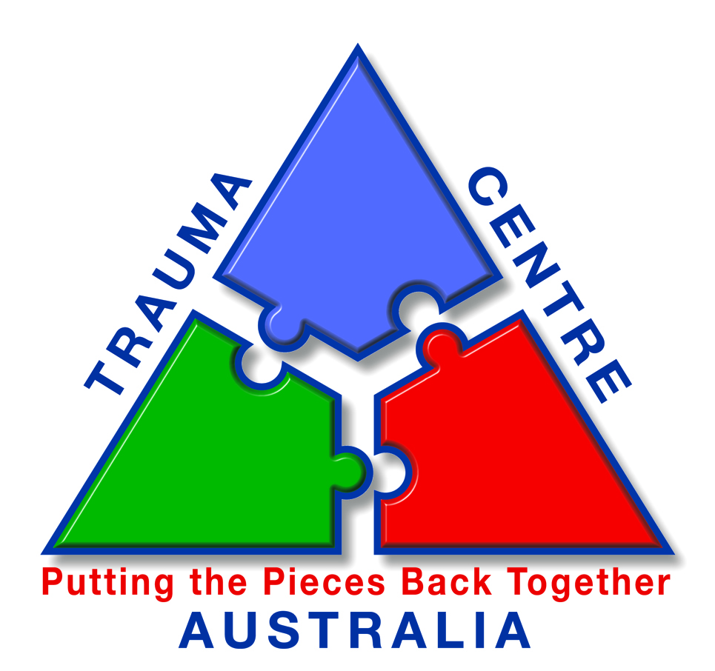
Head Office

Suite 211, Princess Tower Building,
1 Princess Street,
KEW, VICTORIA, 3101
▪ Ph: (03) 9205 9488 ▪
▪ Fax: (03) 9855 2524 ▪
reception@traumacentre.com.au
Regional Office

45 Buckley Street,
MORWELL, VICTORIA, 3840

▪ Ph: (03) 5133 6003 ▪
▪ Fax: (03) 5133 6005 ▪
morwell@traumacentre.com.au

ABN: 76 088 411 170

Invitation to become an Affiliate of Trauma Centre of Australia

Trauma Centre of Australia (TCA) invites suitably qualified trauma practitioners from across all metropolitan and rural areas of Australia to become part of our network of Affiliates. You will become part of a trauma response unit dedicated to offering immediate trauma interventions to those in need.

Becoming an Affiliate Member of Trauma Centre of Australia will provide you with the support of a nationally recognised trauma response organisation. If you are selected (based on the information provided in the Expression of Interest document) we will confirm with you via letter and ask you to sign an agreement.

Being an Affiliate means that you are part of our network of practitioners across Australia who we refer cases to on an as required basis. You are not an employee of the organisation and the work you do with TCA will be as an adjunct to your other professional activities. When cases arise, they are typically allocated on the basis of the regions that need to be covered and the availability of Affiliates.

When cases occur, they are phoned in to our main office in Melbourne and referred to our General Manager, Peter Barta. Affiliates are then contacted to discuss their availability, details of the case, client expectations, remuneration, and to gauge their interest in servicing the client.

Who we are:

Trauma Centre of Australia is a national provider of trauma and critical incident services to businesses and organisations across Australia. Our Trauma Assistance Service aims to enhance people’s focus toward a positive future by helping them to develop skills that will alleviate the problems associated with the traumatic experience.

The Trauma Centre Australia provides the following services:

- Immediate dedicated trauma response 24/7
- Critical incident response policy and procedure development
- Trauma debriefing on site or by telephone
- Individual follow-up counselling, monitoring, and treatment
- Support for individual recovery, or under an effectively supervised group
- Liaison with related practitioners, as well as mediation with insurance companies, employers, solicitors, courts, and medical practitioners
- Develop treatment plans and official assessments, with reports to organisations
- Support in Grief and Trauma
- Confidential advice
- EAP services

How the Trauma Centre operates:

As an Affiliate member of Trauma Centre of Australia, you may be referred cases from our national contracts or through local agencies. We see ourselves as an adjunct to the main focus of your business, one that can provide additional work that is organised and accounted for. Our remuneration package is based on a fee for service arrangement for each case undertaken.

Requirements:

Our main pre-requisites are that you have an interest in working in Trauma, a commitment to availability, and that you are prepared to deliver timely services on-site where possible/appropriate. While the preferred modality of service delivery is CBT, we are happy to discuss your preferences. Ideally, affiliate members will be independent and fully registered with the Australian Psychological Society. People who hold significant experience or background in counselling and managing trauma may also be considered.

To register your interest in becoming a Trauma Associate for Trauma Centre of Australia, please fill in the attached form and email, fax, or post it to our office in Kew using the contact details on the top of this letter.

Head Office

Suite 211, Princess Tower Building,
1 Princess Street,
KEW, VICTORIA, 3101
▪ Ph: (03) 9205 9488 ▪
▪ Fax: (03) 9855 2524 ▪
reception@traumacentre.com.au
Regional Office

45 Buckley Street,
MORWELL, VICTORIA, 3840

▪ Ph: (03) 5133 6003 ▪
▪ Fax: (03) 5133 6005 ▪
morwell@traumacentre.com.au

ABN: 76 088 411 170

EXPRESSION OF INTEREST FORM
TRAUMA PSYCHOLOGISTS / CONSULTANTS

Please fill in the form below to register your interest in becoming a Trauma Psychologist / Consultant with Trauma Centre of Australia. Applications may be submitted by email, post, or fax using the contact details supplied above.

PERSONAL DETAILS

Surname: |  | Given Names:
Home Address:
Suburb: |  | State: |  |  | Post Code:
Postal Address:
Suburb: |  | State: |  |  | Post Code:
Phone (BH): |  | Mobile No:
Fax (BH): |  | Email:

EDUCATIONAL QUALIFICATIONS

I have attached a copy of my resume or a summary of my educational qualifications

RELATED WORK EXPERIENCE

I have attached a copy of my resume or a summary of my relevant work experience

REQUIREMENTS

Please tick the appropriate boxes to confirm that you comply with the following requirements.

I hold current registration with the appropriate State Psychological Board or I am a registered counsellor or social worker registered with the appropriate professional body.

 Please attach evidence of this

I have a minimum of 2 years experience as a practising Psychologist, Counsellor or
Social Worker (you are asked later about your specific experience in working with
clients affected by a traumatic experience).

Total years of experience:

I hold current public liability insurance.

Insurer: Policy valid until:

 Please attach evidence of this

I hold a current drivers licence and have my own transport.

Licence Number: Car/transport Registration No:

I have my own mobile phone/pager that I can be contacted on after business hours.

Mobile/pager Number:

ADDITIONAL INFORMATION
Note: text boxes will expand as you type into them

Please provide an indication of your experience in treating Post-traumatic Stress Disorder and other mental illness associated with trauma:

Please provide any additional comments you would like to make
(Note: questions or queries may also be asked here)

DECLARATION

I, .................................................. , hereby declare that the information provided in this application is, to the best of my knowledge, true and correct as at the date of this document. I understand that this application is an expression of interest only, and hereby authorise a representative of the Trauma Centre of Australia to contact me to discuss further details.

Signed: Date:

